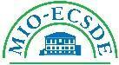
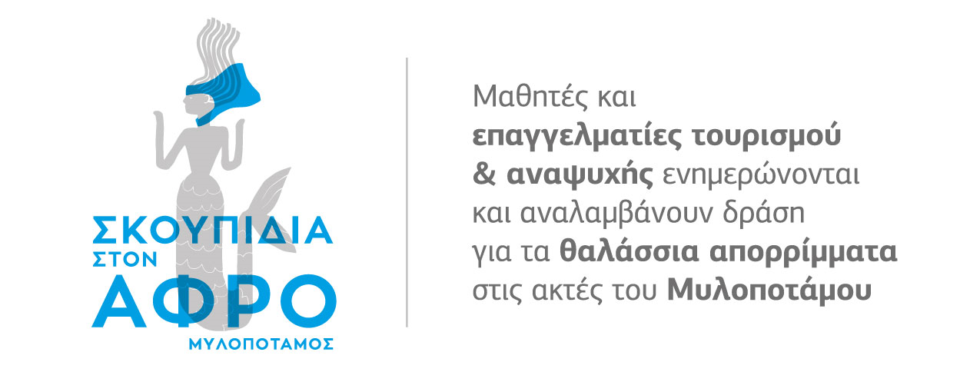
Thursday, 21 October, 17:00 – 20:00 Bali Star Hotel, Crete
2nd Seminar for tourism and leisure entrepreneurs

In the context of the project Waste Ashore -Mylopotamos, and in the light of the completion of the "Pilot Action of the Store Manager" we have the pleasure to invite you to the 2nd Reporting Seminar of Tourism & Leisure entrepreneurs. The Seminar is addressed to all entrepreneurs of the Municipality of Mylopotamos who are interested in taking action to reduce single use plastics in their businesses.

AGENDA
17:00 – 17:20 | Welcome, introductions
17:20 – 17:40 | The Programme Waste Ashore -Mylopotamos
17:40 – 18:00 | Activities taken place so far in the "Pilot Action of a Store Manager" Development of Methodology & Stages of implementation: 1st Seminar, Participation of entrepreneurs, Posters, Creation of artworks
18:00 – 18:20 | Break
18:20– 20:00 | Successes and shortcomings in the Pilot Action, based on the entrepreneurs’ stories, sharing of experiences for ways to overcome the obstacles and how to increase the participation of additional entrepreneurs in the area in related actions for reducing single-use plastics. Discussion & suggestions, coordinated by Prof. Scoullos.

Πράξη ενταγμένη στο Ε.Π. Αλιείας & Θάλασσας 2014-2020 με κωδικό ΟΠΣ (MIS) 5070081.
Με τη συγχρηματοδότηση της Ελλάδας και της Ευρωπαϊκής Ένωσης.
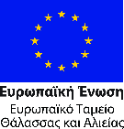 | 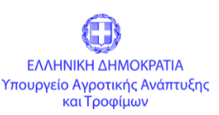 | 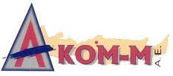 | 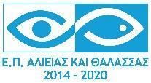 | 